Version 1.0

Revision History

|  |  |  |  |
| --- | --- | --- | --- |
| **Date** | **Version** | **Description** | **Author** |
| 12/12/2019 | 1.0 | details | Tran Van Dat |
|  |  |  |  |
|  |  |  |  |
|  |  |  |  |

Table of Contents

1. Use-Case Name 3

1.1 Brief Description 3

2. Flow of Events 3

2.1 Basic Flow 3

3. Special Requirements 3

3.1 Valid Username and Password 3

3.2 Forgot Username and/or Password 3

4. Preconditions 3

5. Postconditions 3

6. Extension Points 3

# Login

## Brief Description

This use-case defines the steps of logging in to the system as a admin. Admin can easily login by entering his username and password.

# Flow of Events

## Basic Flow

Admin clicks the login button on computer shop’s home page. Then a login form appears, admin fills in that form with his username and password. After that, admin clicks the login button. Eventually, the system redirects to the CT Computer’s home page.

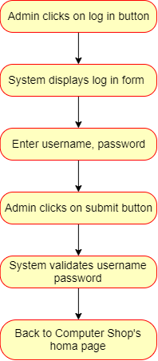

# Special Requirements

## Valid Username and Password

Admin must enter valid username and password.

## Forgot Username and/or Password

The system should have a function to support the users in case of forgetting username

and/or password.

# Preconditions

Admin must already have a CT Computer shop account.

# Postconditions

Admin wait for the system checking his/her account.

# Extension Points

Personal information security should be considered.